
Information Engineering Technology
Project Name: AI Chatbot for Student Queries
Subject: Software Engineering
Semester: 4th

SUBMITTED BY:
Sr. | Name | Roll.No
1 | Arif Hussain | SU91-BIETM-F24-013
2 | Ameer Hamza | SU91-BIETM-F24-018
3 | Asim Shahzad | SU91-BIETM-F24-020
4 | Ahmad Riaz | SU91-BIETM-F24-023

SUBMITTED TO:
Ma, am Javeria Saeed
Submission:
Deliverable 2 – System Design + Prototype
Submission Date:
16 May 2026

Table of Contents
1. Introduction.......................................................................... 3
2. High-Level Design (HLD) ........................................ 3
2.1 Introduction ........................................................................................ 3
2.2 Purpose ............................................................... 3
2.3 System Architecture Diagram ........................................ 3
2.4 Module Decomposition Diagram ........................................ 4
3. Low-Level Design (LLD) ........................................ 6
3.1 Introduction ........................................................................................ 6
3.2 Flowchart Diagram ........................................ 6
3.3 Class Diagram ..................................................................... 7
3.4 Sequence Diagram .................................................... 8
3.5 ERD Diagram ...................................................... 9
4. UI Design ................................................................................. 10
5. Working Prototype (Basic Implementation) ........................................ 11
5.1 Introduction ..................................................................... 11
5.2 Purpose of Prototype ........................................ 11
5.3 Technologies Used ........................................ 11
5.4 Implemented Features ........................................ ……………11
5.5 Prototype Workflow ........................................ 12
5.6 Sample Interaction ............................................................ 12
5.7 Code for AI Chatbot ........................................ 13
5.8 Login Screen ....................................................................................... 15
5.9 Student Dashboard ........................................ 15
5.10 AI Chatbot Interface ........................................ ………………….15
5.11 Notification Screen ........................................ 16
5.12 Running Prototype Interface........................................................ 16

System Design Document
1. Introduction
The System Design phase transforms project requirements into a structured design model that explains how the system will work. It defines the architecture, modules, data flow, and interaction between system components before implementation begins. For the Smart Campus System, the design focuses on creating an AI-powered chatbot that helps students access academic and campus-related information quickly and efficiently. The system architecture and UML models provide a clear representation of the system structure and workflow.
2. High-Level Design (HLD)
2.1. Introduction
High-Level Design (HLD) provides a general overview of the Smart Campus System and explains the overall structure of the system. It identifies the major components, modules, and interactions between different parts of the project. HLD helps developers understand how the system works before implementation starts and provides a clear picture of system architecture and functionality.

2.2. Purpose
The purpose of High-Level Design is to represent the complete structure of the system and define how major components communicate with each other. It helps organize system functionality into different modules and provides a roadmap for development and implementation.
2.3. System Architecture Diagram

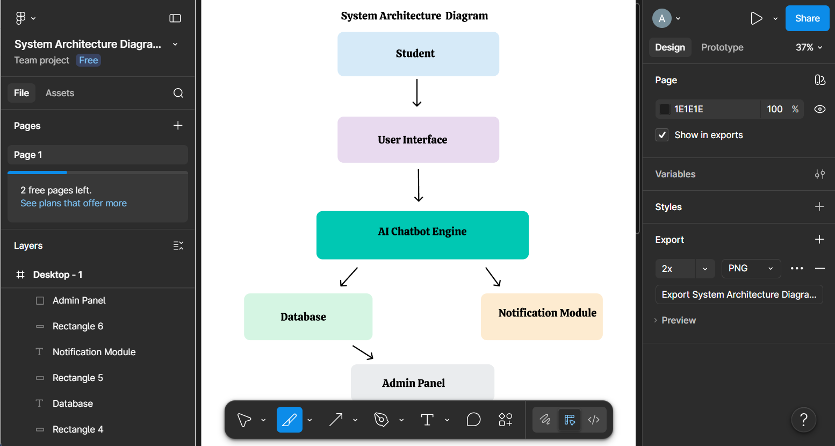

Purpose
The System Architecture diagram provides a high-level view of the Smart Campus System and shows communication between users, chatbot processing, database, and administration modules.
Working Process:
- The student enters a query through the interface.
- The request is sent to the AI chatbot.
- The chatbot processes the request.
- The system checks the database for required information.
- The response is generated.
- The result is displayed to the student.
- Admin can update records and notifications.
Explanation:
The system architecture diagram represents the overall structure of the Smart Campus System and shows how users, chatbot processing, database systems, and administration modules interact. It explains the communication flow and working process between all major system components.
2.4. Module Decomposition Diagram

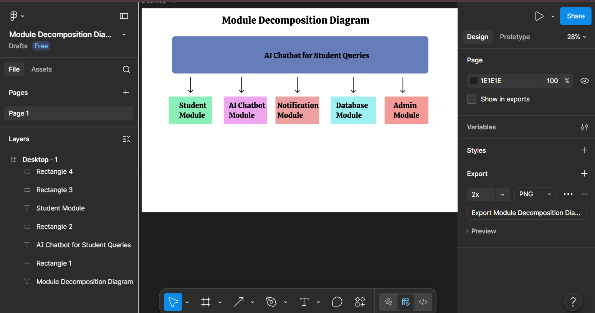

Purpose
The purpose of module decomposition is to break the complete system into separate functional components. It helps organize the project structure and clearly define the responsibilities of each module.

Working Process
- Students interact with the system through the user interface.
- The Student Module sends requests to the AI Chatbot Module.
- The AI Chatbot processes the query and communicates with the Database Module.
- The Database retrieves required information.
- The Notification Module sends reminders and announcements.
- The Admin Module manages and updates system records.
- The processed response is returned to the student.

Explanation
The Smart Campus System is divided into the following modules:

Student Module
It handles student activities and allows users to:
- Ask chatbot questions
- View attendance
- Check exam schedules
- View timetable information

AI Chatbot Module
It is responsible for processing and responding to student queries:
- Receive requests
- Process user questions
- Generate responses

Database Module
It stores and manages system data:
- Student records
- Attendance data
- Exam schedules
- Fee information

Notification Module
It handles communication updates:
- Send reminders
- Send announcements
- Deliver notifications

Admin Module
It allows administration management:
- Update information
- Manage system data
- Monitor activities

3. Low-Level Design (LLD)
3.1. Introduction
Low-Level Design describes the internal structure and detailed working of the Smart Campus System. It provides a detailed representation of system components, workflows, object interactions, and database structure through UML diagrams and design models. LLD focuses on how individual modules and system elements operate internally.

3.2. Flowchart Diagram

Purpose:
The flowchart represents the step-by-step flow of system operations.
Working Process:
- Student opens the application.
- Student enters a question.
- Chatbot receives the query.
- System checks database information.
- Chatbot generates a response.
- Response is displayed to the student.
Explanation:
The flowchart visually shows the sequence of activities performed by the system.

3.3. Class Diagram
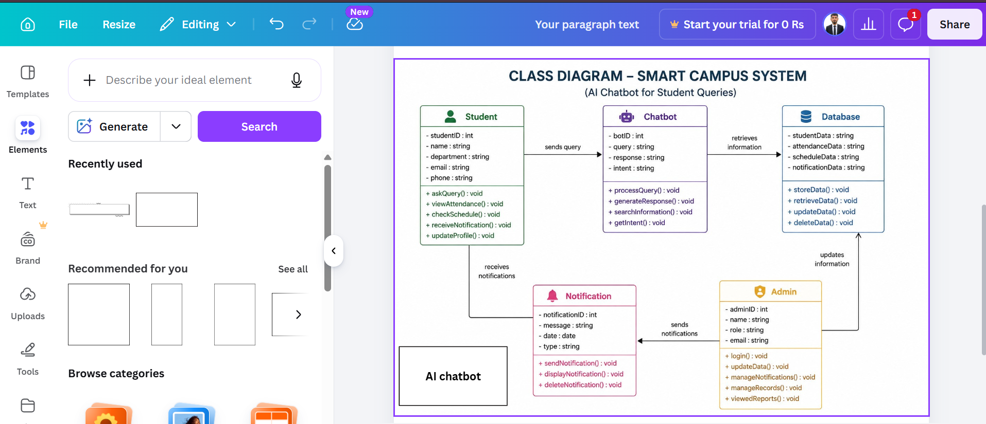
Purpose:
The Class Diagram represents system classes, attributes, methods, and relationships.
Working Process:
Student interacts with the chatbot class. The chatbot processes requests and communicates with the database. Admin manages and updates system information.
Explanation:
The Class Diagram shows the internal structure and object relationships used in the system.

3.4. Sequence Diagram
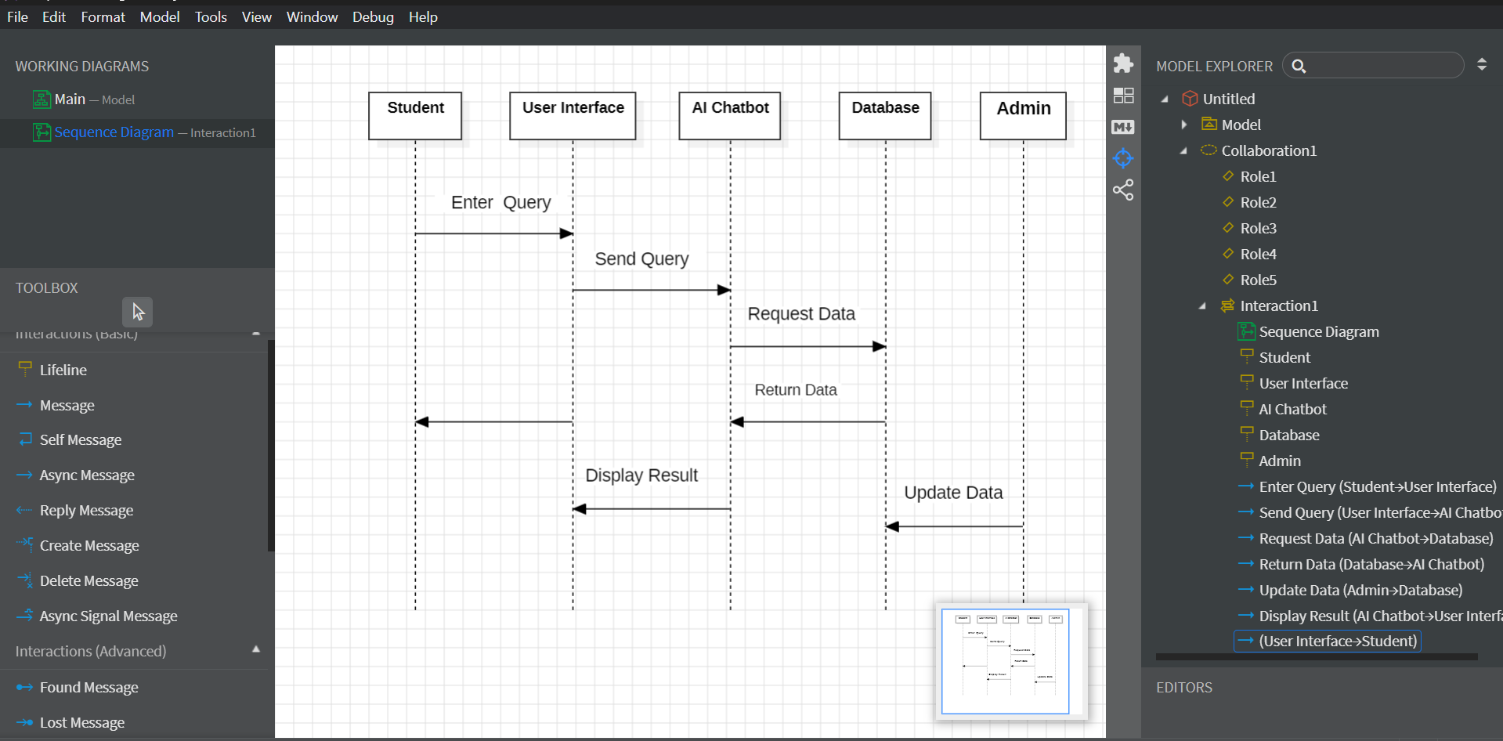
Purpose:
The Sequence Diagram shows message flow and communication between system components over time.
Working Process:
- Student sends request.
- Interface forwards query.
- Chatbot processes request.
- Database returns information.
- Chatbot sends response back.
Explanation:
The Sequence Diagram represents interaction order among system components.

3.5. ERD Diagram
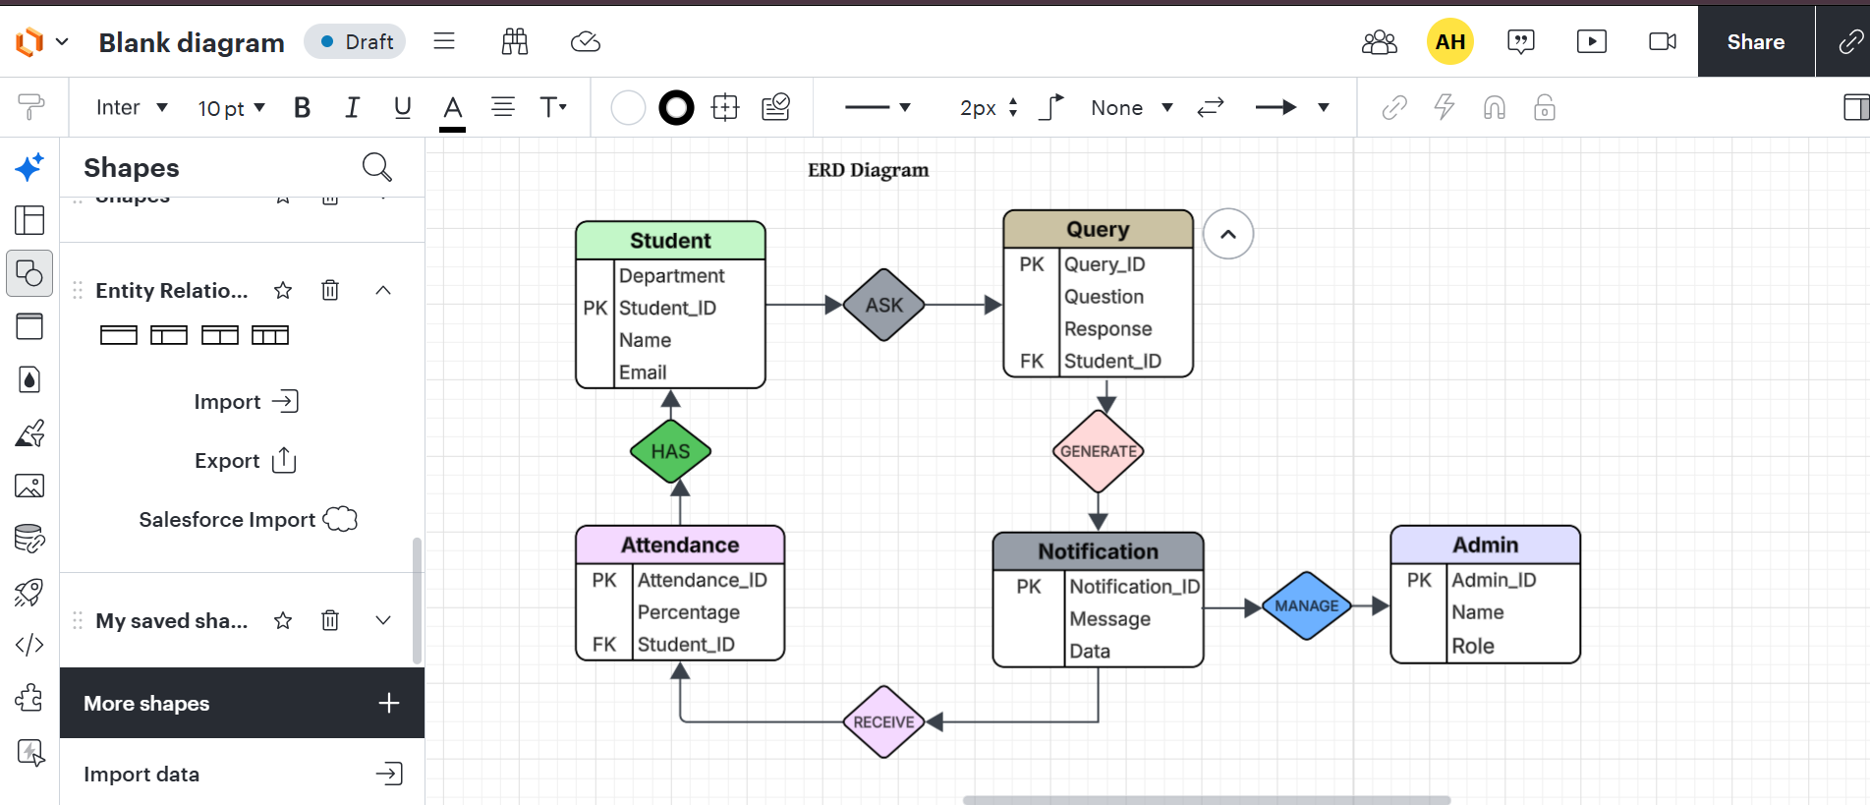
Purpose:
The ERD shows data entities and relationships used in the database.
Working Process:
Student information, queries, attendance records, notifications, and admin data are stored and connected through relationships.
Explanation:
The ERD defines the database structure and data organization.

4. UI Design
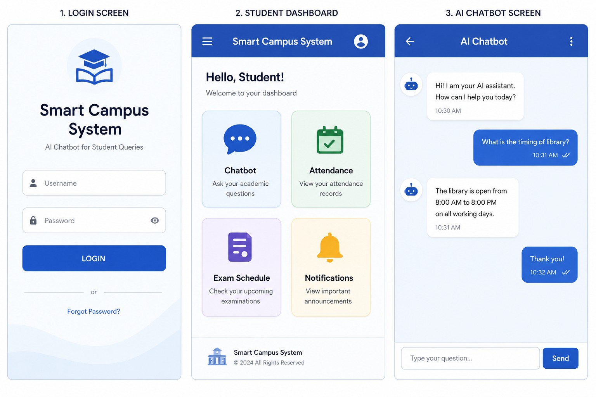
Purpose:
The UI Design represents system screens and user interaction.
Working Process:
Students log in, open the dashboard, interact with the chatbot, and access academic information.
Explanation:
The UI provides a user-friendly environment for interacting with the system.

5. Working Prototype (Basic Implementation)
5.3. Technologies Used

Technology | Purpose
Python | Backend logic
Streamlit / Gradio | User Interface
MySQL Workbench | Database
Visual Studio Code | Development Environment

